Sprint 3 Plan

Decentralized Application Framework (DAPPF)

Kirill, Anthony, Garrett, Shishir, Vincent

11/2/21

Completion Date: 11/15/21

Revision Number: 1

Revision Date: 11/2/2021

**Goal:**

The goal of this sprint is to add efficiency, speed, and consistency to our framework. We also will be adding event listeners to the framework, for our MVP.

**User Stories:**

User story 1 (“As a developer, I would like to bind event listeners”)

* Task 1: Make the developer able to add an event listener on incoming data (2 hours)
* Task 2: Make the developer able to add an event listener on new neighbor (1 hour)
* Task 3: Make the developer able to add an event listener on disconnected neighbor (3 hours)

Total for user story 1: 6 hours

User story 2 (“As a developer, I would like to cache my user’s data”)

* Task 1: Create a cache which keeps requests in memory in the event it can be used again so we don't have to repeatedly calculate the same data (4 hours)
* Task 2: Allow for an arbitrary user-specified caching schema (4 hours)

Total for user story 2: 8 hours

User story 3 (“As a developer, I would like to implement runnables”)

* Task 1: Create a task pool with a set of tasks which are executed after a delay (6 hours)

Total for user story 3: 6 hours

User story 4 (“As a developer, I would like to check the communication packet validity”)

* Task 1: Create packet validation which ensures the packet structure is correct (2 hours)
* Task 2: Create data validation which checks if the number of bytes needed for a request is present (3 hours)

Total for user story 4: 5 hours

**Team Roles:**

Vincent: Team lead, Developer

Kirill: Developer

Anthony: Developer

Garrett: Scrum Master, Developer

Shishir: Developer

**Initial Task Assignment:**

Vincent:

* User Story: “As a developer, I would like to cache my user’s data”
* Task 1

Kirill:

* User Story: “As a developer, I would like event listeners”
* Task 1

Anthony:

* User Story: “As a developer, I would like to implement runnables”
* Task 1

Garrett:

* User Story: “As a developer, I would like to validate my user’s data”
* Task 1

Shishir:

**Initial Burnup Chart:**

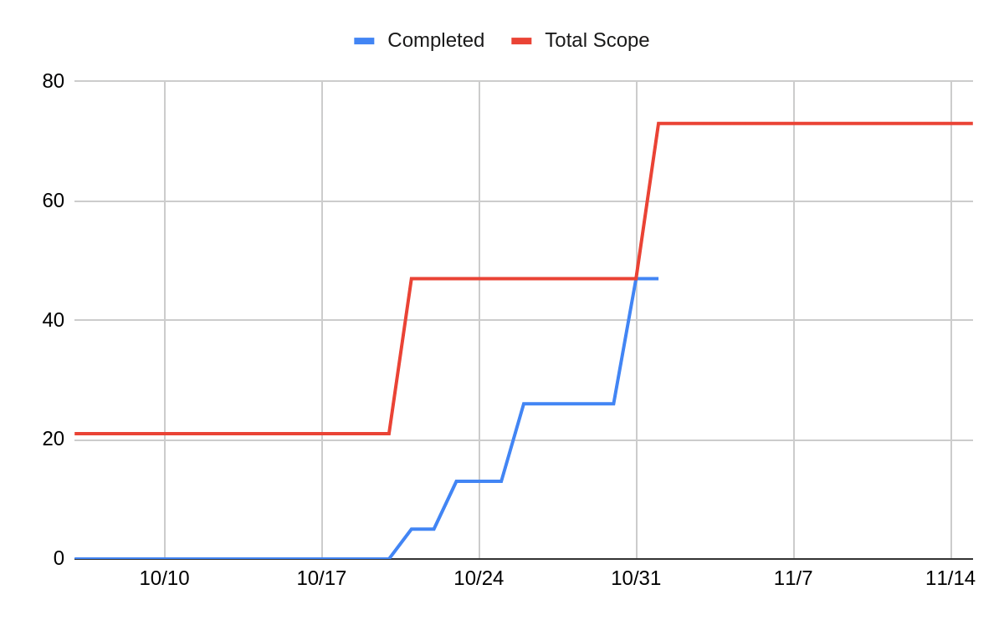

**Initial Scrum Board:**

| **User Stories** | **Tasks Not Started** | **Tasks In Progress** | **Tasks Completed** |
| --- | --- | --- | --- |
| “As a developer, I would like event listeners” | Task 2, Task 3 | Task 1 |  |
| “As a developer, I would like to cache my user’s data” | Task 2 | Task 1 |  |
| “As a developer, I would like to implement runnables” |  | Task 1 |  |
| “As a developer, I would like to validate my user’s data” | Task 2 | Task 1 |  |

**Scrum Times:**

Meetings:

* Tuesday at 5pm
* Wednesday at 5pm
* Saturday at 12pm

Scrum meeting:

* Tuesday at 1 pm